How to handle calendar in Selenium Webdriver and web table

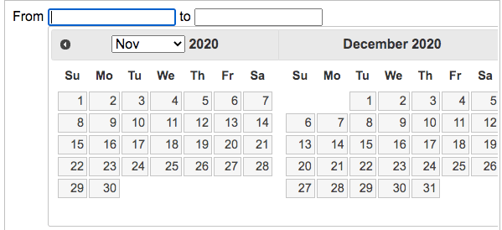

I will show you how you can handle the calendar in Selenium Webdriver using the table approach.

I will use [JQuery Date picker](https://jqueryui.com/datepicker/) for example but you can take any example because the approach will remain the same. I will be using [findElements](http://learn-automation.com/difference-between-findelement-and-findelements-in-selenium-webdriver/)methods to find all the dates and then will get the text and will click on the respective date.

The below image is an example of a Date picker which is a JQuery widget



**Approach 1**

Step 1- Click on calendar

Step 2- Get all td of tables using findElements method

Step 3- using for loop get the text of all elements

Step 4- using if else condition we will check the specific date

Step 5- If the date is matched then click and break the loop.

**Approach 2- You can find the dates using XPath or CSSSelector and click on the dates directly.**

**Approach 3- You can also use**[JavaScriptExecutor](http://learn-automation.com/javascript-in-selenium-webdriver-and-different-usage/)**which can set the date value directly in the date field.**